DETAILED LIST OF CHANGES ON 13/08/2026
- BillionTests→ BillionTests.AI™.
- BT Card → BTCARDX™
- At place of Kidney decease only → Urinary tract infections (UTIs) , Kidney disease, Kidney stones, Diabetes, Dehydration and Liver or Bile duct problems [Slide 8]
- Change spellings from American → British English, e.g. “color” → “colour” and “analyzer” → “analyser.”
- → Add separate page for news & articles [slide 18]
  - Add 2 news shared
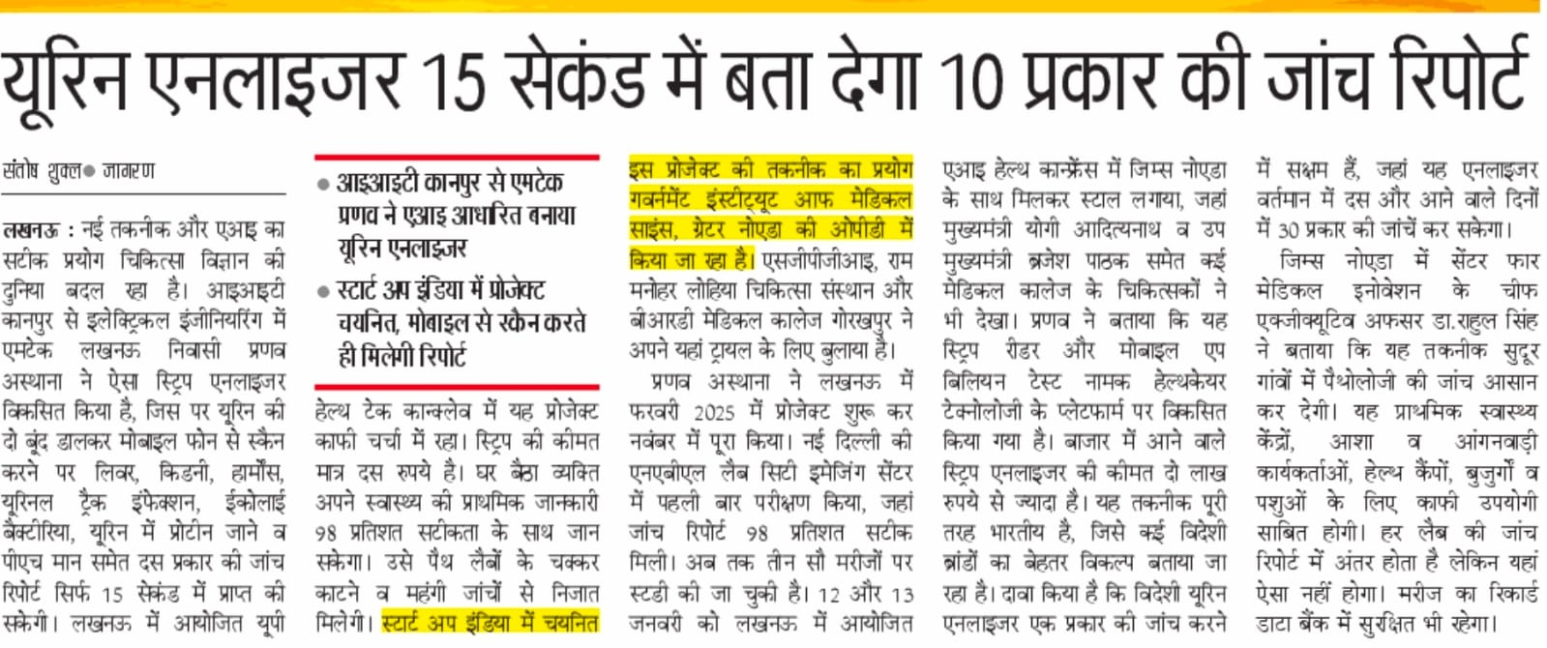
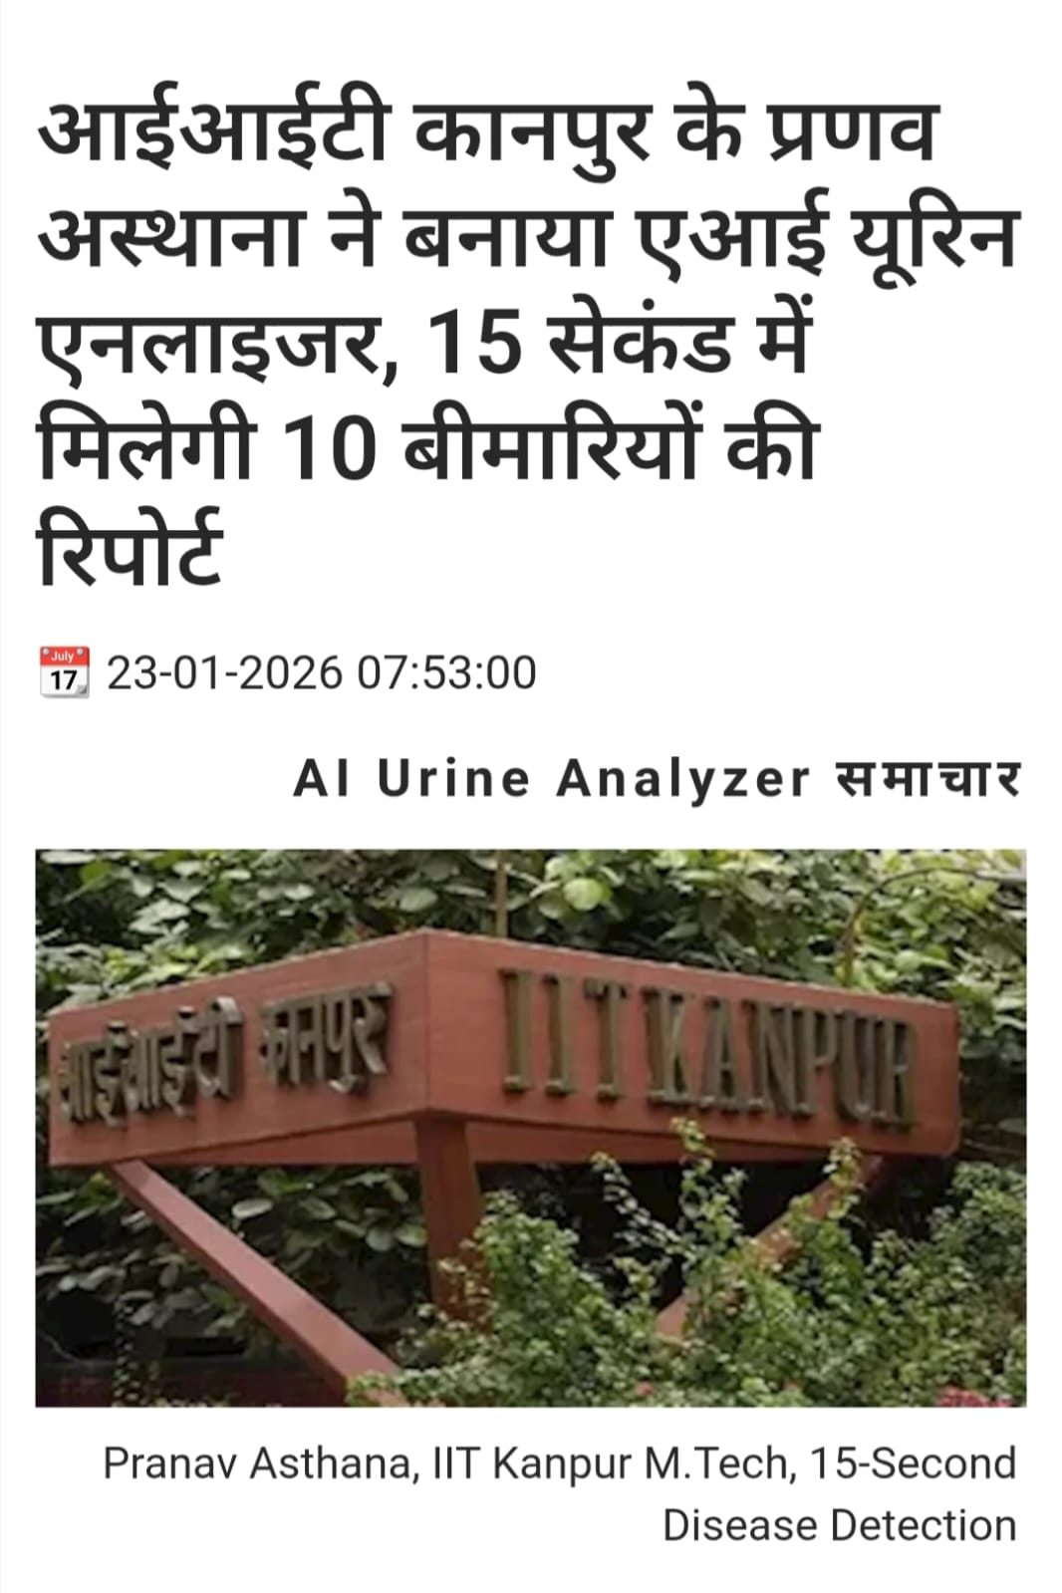

- Replace Sahil name and Pic with → Priyadarshani
- In Address → Ahmedabad, Bhubaneshwar, Bombay, Lucknow, Mohali, Washington DC

- Mention following Founders:
  - Maninder Pal Singh Sethi — Co-founder & CBO
  - Alok Kulshrestha — Co-founder & COO
  - Abhishek Chaturvedi — Co-founder & CPO
  - Priyanka Priyadarshini — Co-founder & CGO
Sr. No. | Name | Designation | Introduction | Photograph
1 | Maninder Pal Singh Sethi | Co-founder & CBO | Post Graduate in Chemistry (Hons School) from Punjab University Chandigarh. Having rich experience of 44 years in Business Development of capital goods. 10 years dedicated to AI enabled and Lab Testing Solution | 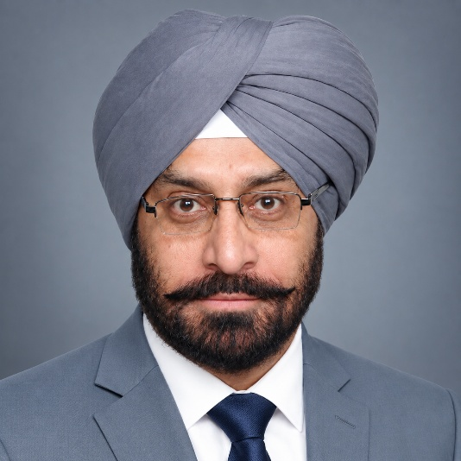
2 | Alok Kulshrestha | Co-founder & COO | Alok Kulshrestha, postgraduate from IET Lucknow. Having over five years of experience in technical sales and AI based solutions. | 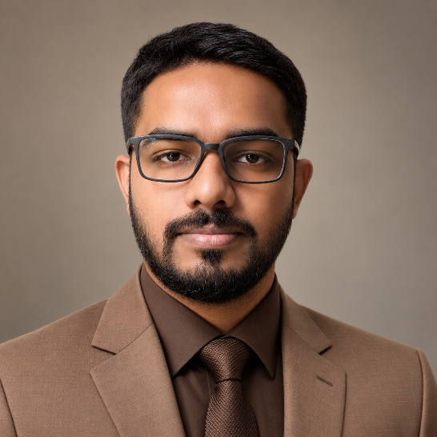
3 | Abhishek Chaturvedi | Co-founder & CPO | Postgraduate in Biochemistry and have a total of 5 years of professional experience, including the AI based product development and pharmaceutical sales | 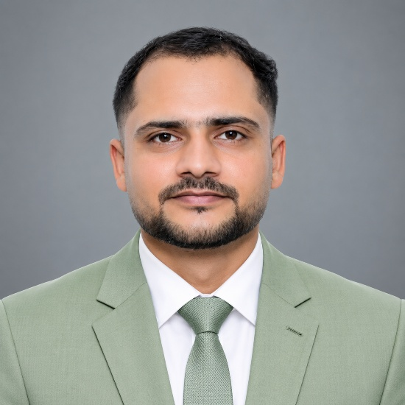
4 | Priyanka Priyadarshini | Co-founder & CGO |  | 

  - Pranav Asthana — Co-Inventor & Platform Head
  - Ritu Mishra — Co-Inventor & Head of Innovation
  - Pramod Prasad — RevOps Leader

- Extensible to 30+ diagnostic strips across human and animal health / human, cattle, pet → Adaptable to all standard diagnostic urine test strip variants across human health diagnostics licensed under CDSCO (Central Drugs Standard Control Organization) [Slide 5]

- If cost Rs.10 or Rs.20 mentioned anywhere remove it → Ultra low-cost VS Rs.100-300 by any standard diagnostic labs. [Slide 7]

- Kidney → Protein: UTI, Kidney disease, Kidney stones, Diabetes, Dehydration and Liver or Bile duct problems. The other listed parameters remain substantially similar.

- Vision statement removed from first slide

- 10+ parameters→ kidney, blood sugar, UTI + 7 more parameters [Slide 11]

- Claim of (Ultra-low cost<2 $) removed

- 30+ strip types across human and animal health→ any standard generic test strip variant across human health diagnostics licensed under CDSCO

- Slide 18 containing previous endeavors of team, checko, upjao, etc removed

- Added accreditation proof from City Imaging (NABL) [slide 22]

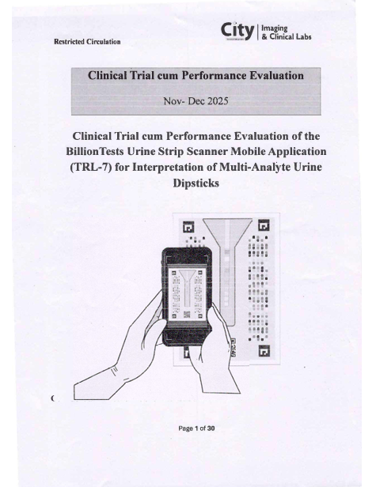 | 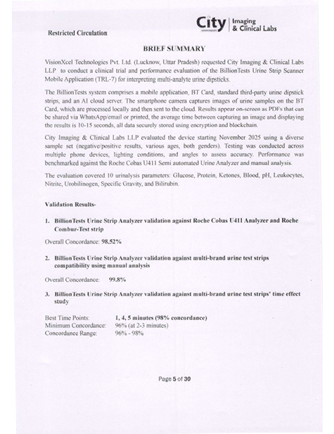

- Role change: Sahil Reddy→ Priyanka Priyadarshini

- Color scheme changed to match that of the website

21. Minor copy/terminology changes

Original | V3
BillionTests | BillionTests.AI
analyzer | analyser
color | colour
screenable | screen-able
urinalysis | urine analysis in Future Expansion
Ready made and well established | Ready made and well-established
BT Card | BTCARDX
30+ diagnostic strips | all standard urine strips licensed under CDSCO
10+ urine parameters | kidney, blood sugar, UTI + 7 more
<$2 per test | Ultra-low cost
₹10 per scan | Low cost scan
These are visible across the corresponding slides.

Bottom line
The V3 deck's biggest strategic changes are:
- Rebrand: BillionTests → BillionTests.AI
- More regulatory positioning: repeated emphasis on CDSCO-licensed standard strips
- Less aggressive pricing claims: removal of ₹10/test, ₹10/scan, <$2/test and some specific percentage comparisons
- More concrete product messaging: kidney + blood sugar + UTI + 7 parameters
- New product name: BTCARDX
- New PR/traction slide: BillionTests.AI in news
- Complete team makeover: 8-person leadership/development team with photos and bios
- Old IIT/product-track-record narrative removed, including Shreyan Awasthi's profile
- New documentary validation slide: City Imaging/NABL evidence
- Deck expanded: 21 → 23 slides
- Brand/TM and visual/header treatment updated throughout

